 | ISCG6421 – GUI Programming  Semester 2, 2020  Assignment 1
School of Computing and Information Technology | Submission Time: 8:30 a.m.  Save Point 1: Monday 10th August 2020  Save Point 2: Monday 24th August 2020  Final Submission: Monday 31st August 2020  Course Weighting: 40%  Marks: 100

Contents
Assignment objectives: 2
Introduction 2
Database 2
Guide to the Assignment 3
Test Cases 4
Save Points 4
Expectations: 4
Application Requirements 5
Task 1: Main Menu 5
Required tests: 5
Task 2: Arena Maintenance 7
Required tests: 7
Task 3: Challenge Maintenance 10
Required tests: 11
Task 4: Competitor Maintenance 13
Required tests: 13
Task 5: Event Maintenance 16
Required tests: 16
Task 6: Enter Competitors into Challenges 19
Required tests: 19
Task 7: Competitor Report 21
Required tests: 21
Task 8: Event Report 22
Required tests: 22
Marking 23
Notes on marking 23
Have a query? Want to improve your work? 23
Assignment 1 Progress Log 24
Deliverables 25
Soft 25
Affected Performance Consideration 26
Assistance to other Students 26
Beneficial Assistance 26
Unacceptable Assistance 26
Programming Standards for C Sharp Courses 27
Internal Documentation 27
Layout 27

Assignment objectives:

There are two objectives for this assignment:
- To demonstrate the use of the C# language for the creation of an effective database front end by developing forms which:
  - Visually present database information.
  - Demonstrate appropriate user and programmatic navigation.
  - Allow the user to enter new data and change existing data.
- To demonstrate the testing, debugging and documentation of a C# application by:
  - Using the available debugging tools to debug a program.
  - Developing test cases appropriate to a GUI approach.

Introduction

This assignment is based on a case study about the New Zealand E-Sports League, an agency that sets up E-Sports events within the Auckland region. The agency requires a front-end application for their database which has already been developed. You, the programmer, must complete the work by writing an application, in the language C#, which will allow the users to maintain the records stored in the database and produce the reports that they need.

Database

You are provided with an MS Access database for this assignment named NZESL. Please leave the structure of this database as it is and do not add any tables or queries. The NZESL database has the following tables (note that the primary keys are underlined, and foreign keys are indicated by a ‘*’ symbol):

ARENA (ArenaID, ArenaName, StreetAddress, Suburb, City, PhoneNumber)
EVENT (EventID, EventName, ArenaID*, Status, Capacity, EventDate)
COMPETITOR (CompetitorID, UserName, FirstName, LastName, Gender, DateOfBirth, EmailAddress)
CHALLENGE (ChallengeID, ChallengeName, EventID*, StartTime, Status, Capacity)
ENTRY (ChallengeID*, CompetitorID*, Status)

Guide to the Assignment

- You are to write the code for Assignment 1 in C# using Visual Studio .NET Community 2017

- You are to use the OleDb objects to interact with the MS Access database tables.

- Make sure that your C# project database connection points to c:\Temp and make sure the MS Access database file is placed in c:\Temp

- You are to use the shared dataset model (see the Shared Data, Wallace Events and Glendene Cat Care projects, as discussed in class, and notes on databases in C#).

- You are to use programming logic (master-detail relationships in conjunction with ‘for-each’ loops) to create the reports – please do not use Crystal Reports.

- Your interface should conform to the standards discussed in class and must match the screen designs provided in this document – please note the interface in GlendeneCatCare has limitations and should be used as a starting point but not as an exemplar.

- Use the metadata provided in MS Access database tables as the data dictionary from which you can make decisions on what is valid or invalid data.

- Your test cases must include all of the tests that are listed as required in the assignment document and your tests must be repeatable and independent. You may use the data in the MS Access tables as the basis for your loaded test data.
  - Select your input test data to make your tests as independent as possible. For example: if you are testing that a program deletes an event record then use, as test data, an event that exists in the loaded test data NOT an event that was input in an earlier test.
  - Remember to verify the expected results of the tests with other tests if possible. For example, if you have a test that adds a new record, then use the ‘view’ facility in the program to check that the record has been added.
  - The numbering of your tests MUST correspond with the numbers in this document. If you create your interface so that a test is redundant (e.g. you use radio buttons for selection) you must still include the test in your test cases along with an explanation as to why it is redundant. Check all instances of this circumstance with the lecturer.

- You must submit a work-in-progress version of your assignment for each of the Save Points on Moodle. Minimum requirements implemented are listed below in the Save Points section.

- You must submit any questions and/or queries regarding this assignment to the lecturer before the Question Submission Deadline in the course schedule.

Test Cases

Please using the following format for your test cases and leave the actual outcomes column blank:

Requirement to test | Test Data Input | Expected Outcomes | Actual Outcomes

Save Points

There is an expectation that you will have completed certain aspects of your assignment at each save point submission. If your submission does not meet the expectations of the save point, your overall mark for the final submission may be penalised.

Expectations:

Save Point 1:
- Main Menu and all other forms created with User Interface designs implemented.
- Main Menu linked to each of the Maintenance and Report forms through Button_Click events.
- Task 1 complete,
- Task 2 Part 1, 2 ,3 ,4 (a, b, c, d) completed.

Save Point 2:
- Tasks 1, 2, 3, 4, 5 completed.
- Partial progress towards completing Task 6, 7 or 8.

Application Requirements

Write a Windows application in C# that allows the user to do the tasks specified below and to provide reasonably comprehensive testing documentation that proves that the application performs all of the tasks. Please note that these requirements are non-negotiable.

Task 1: Main Menu
- This task allows the user to access all the forms and the reports in the system and exit the application.
- When run, this task will create a data module object (containing the OleDb objects used with the MS Access database tables) the address of which will be passed on to all the other forms via a parameter.

Required tests:

  - Main menu is displayed when the program is run.

Main Menu Design
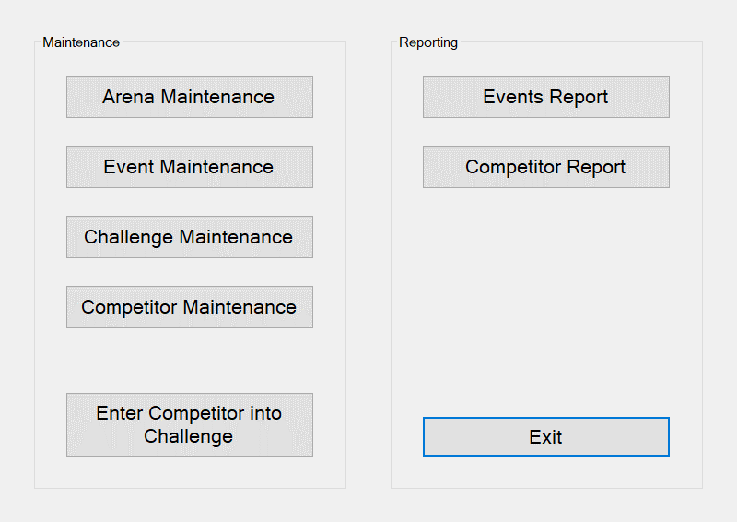

Task 2: Arena Maintenance

- Display the arenas’ names in a list.
- Allows the user to navigate between arenas in the list.
- Display a selected arena’s details (arena id, arena name, street address, suburb, city, and phone number) in a read-only format.
- If the user clicks on the Add Arena button, then
  - The Previous, Next, Return, Update Arena and Delete Arena buttons are disabled, and the list should disappear.
  - A panel should appear (showing Save Arena and Cancel buttons) allowing the user to enter values for the new arena’s name, street address, suburb, city, and phone number.
  - If the user enters valid data for all fields and clicks on the Save Arena button, then a new Arena record is saved in the database and the message “Arena added successfully” is displayed.
  - If the user clicks on the Cancel button then panel should disappear, the Previous, Next, Return, Update Arena and Delete Arena buttons are enabled, and the list should reappear.
- If the user clicks on the Update Arena button, then
  - The Previous, Next, Return, Add Arena and Delete Arena buttons are disabled and the list should disappear.
  - A panel should appear (showing Save Changes and Cancel buttons) allowing the user to change the values for the arena’s name, street address, suburb, city, or phone number.
  - If the user makes valid changes to any of the allowable fields and clicks on the Save Changes button, then the arena record is updated in the database and the message “Arena updated successfully” is displayed.
  - If the user clicks on the Cancel button then the panel should disappear, the Previous, Next, Return, Add Arena and Delete Arena buttons should be enabled and the list should reappear.
- If the user clicks on the Delete Arena button and the selected arena has no events, then the user is asked to confirm the deletion – if the user confirms the deletion then the arena is deleted from the database and the message “Arena deleted successfully” is displayed.
- If the user clicks on the Delete Arena button and the selected arena has events, then the error message “You may only delete arenas that have no events” is displayed.
- If the user clicks on the Return button, then focus is returned to the Main Menu.

Required tests:

  - Add a new arena with valid data in all fields.
  - Update an existing arena’s name with valid data.
  - Update an existing arena’s street address with valid data.
  - Update an existing arena’s suburb with valid data.
  - Delete an existing arena that has no events.
  - Attempt to add a new arena with an invalid name but with valid data in all other fields.
  - Attempt to add a new arena with an invalid street address but with valid data in all other fields.
  - Attempt to update an existing arena with an invalid name.
  - Attempt to delete an existing arena that has events.

Arena Maintenance: Screen Design 1
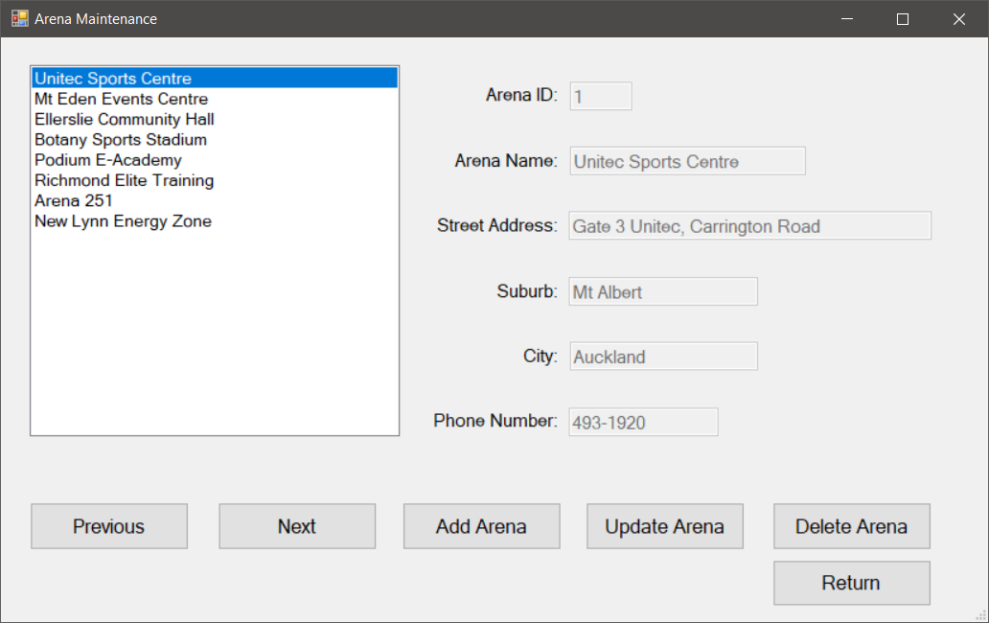

Arena Maintenance: Screen Design 2
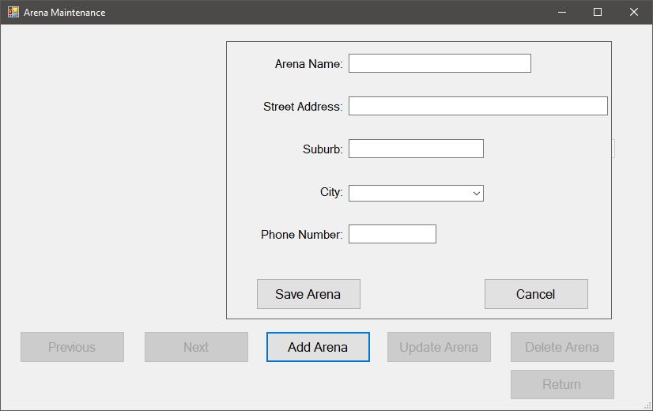

Arena Maintenance: Screen Design 3
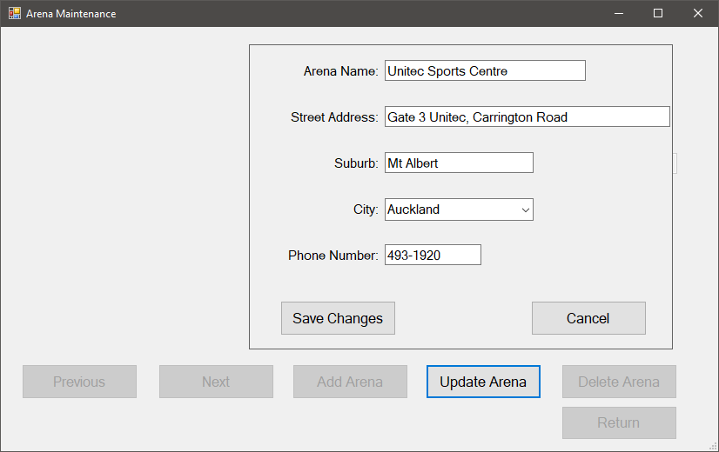

Task 3: Challenge Maintenance

- Display the Challenge ids in a list.
- Allows the user to navigate between challenges in the list.
- Display a selected challenge’s details (challenge id, challenge name, event id, event name, start time, status, and capacity) in a read-only format.
- If the user clicks on the Add Challenge button, then
  - The Previous, Next, Return, Update Challenge, Delete Challenge, Mark Challenge as Finished, and Mark Challenge as Completed buttons are disabled and the list should disappear.
  - A panel should appear (showing Save Challenge and Cancel buttons) allowing the user to enter values for the new challenge’s name, event (using combo boxes), start time, status (using a combo box), and capacity (using a number picker).
  - If the user enters valid data for all fields and clicks on the Save Challenge button, then a new challenge record is saved in the database and the message “Challenge added successfully” is displayed.
  - If the user clicks on the Cancel button then the panel should disappear, the Previous, Next, Return, Update Challenge, Delete Challenge, Mark Challenge as Finished, and Mark Challenge as Completed buttons are enabled and the list should reappear.
- If the user clicks on the Update Challenge button, then
  - The Previous, Next, Return, Add Challenge, Delete Challenge, Mark Challenge as Finished, and Mark Challenge as Completed buttons are disabled and the list should disappear.
  - A panel should appear (showing Save Changes and Cancel buttons) allowing the user to change the value for the challenge’s name, time and capacity (using a number picker).
  - If the user makes valid changes to any of the allowable fields and clicks on the Save Changes button, then the Challenge record is updated in the database and the message “Challenge updated successfully” is displayed.
  - If the user clicks on the Cancel button then panel should disappear, the Previous, Next, Return, Add Challenge, Delete Challenge, Mark Challenge as Finished, and Mark Challenge as Completed buttons are enabled and the list should reappear.
- If the user clicks on the Delete Challenge button and the selected challenge has no entries, then the user is asked to confirm the deletion – if the user confirms the deletion then the challenge record is deleted from the database and the message “Challenge deleted successfully” is displayed.
- If the user clicks on the Delete Challenge button and the selected challenge has entries, then the error message “You may only delete a challenge that has no entries” is displayed.
- If the user clicks on the Mark Challenge as Finished button and the selected challenge has a status of ‘Scheduled’ then the challenge’s status is changed to ‘Finished’ in the database, and the message “Challenge marked as finished” is displayed.
- If the user clicks on the Mark Challenge as Finished button and the selected challenge does not have a status of ‘Scheduled’, then the error message “Only scheduled challenges can be marked as finished” is displayed.
- If the user clicks on the Mark Challenge as Completed button and the selected challenge has a status of ‘Finished’ then the challenge’s status is changed to ‘Completed’ in the database, all entries linked to the challenge are deleted and the message “Challenge marked as completed” is displayed.
- If the user clicks on the Mark Challenge as Completed button and the selected challenge does not have a status of ‘Finished’, then the error message “Only finished challenges can be marked as completed” is displayed.
- If the user clicks on the Return button, then focus is returned to the Main Menu.

Required tests:

  - Add a new challenge with valid data in all fields.
  - Update an existing challenge’s capacity with valid data.
  - Update an existing challenge’s name with valid data.
  - Delete an existing challenge that has no entries.
  - Mark as finished an existing scheduled challenge.
  - Mark as completed an existing finished challenge.
  - Attempt to delete an existing challenge that has at least one entry.
  - Attempt to mark as finished an existing completed challenge.
  - Attempt to mark as completed an existing scheduled challenge.

Challenge Maintenance: Screen Design 1
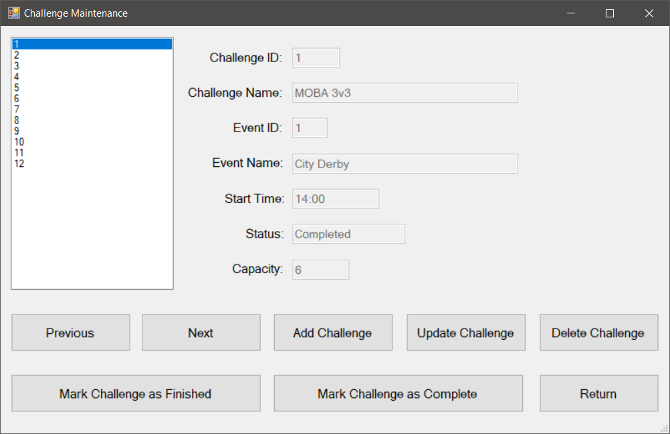

Challenge Maintenance: Screen Design 2
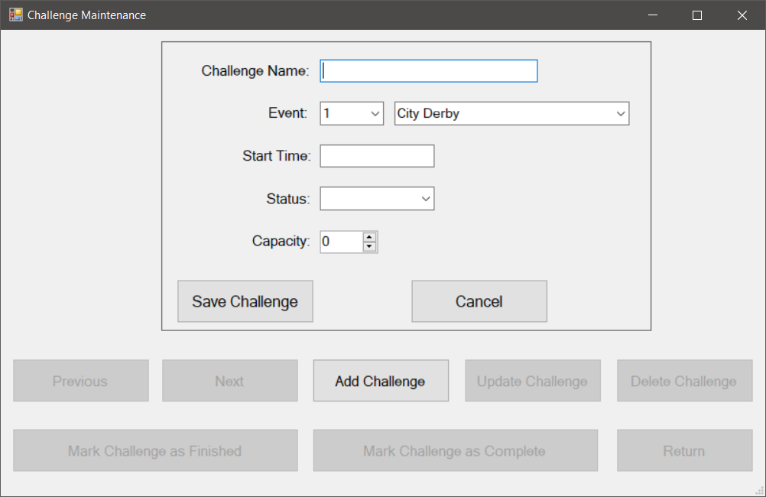

Challenge Maintenance: Screen Design 3
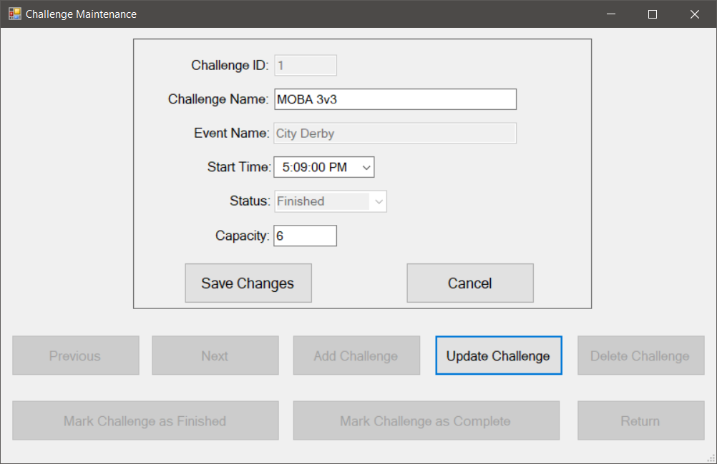

Task 4: Competitor Maintenance

- Display the competitors’ usernames in a list.
- Allows the user to navigate between competitors in the list.
- Display a selected competitor’s details (competitor id, username, first name, last name, gender, date of birth, and email address) in a read-only format.
- If the user clicks on the Add Competitor button, then
  - The Previous, Next, Return, Update Competitor and Delete Competitor buttons are disabled and the list should disappear.
  - A panel should appear (showing Save Competitor and Cancel buttons) allowing the user to enter values for the new competitor’s username, first name, last name, gender (using a combo box), date of birth (using a date picker), and email address.
  - If the user enters valid data for all fields and clicks on the Save Competitor button, then a new competitor record is saved in the database and the message “Competitor added successfully” is displayed.
  - If the user clicks on the Cancel button then panel should disappear, the Previous, Next, Return, Update Competitor and Delete Competitor buttons are enabled and the list should reappear.
- If the user clicks on the Update Competitor button, then
  - The Previous, Next, Return, Add Competitor and Delete Competitor buttons are disabled and the list should disappear.
  - A panel should appear (showing Save Changes and Cancel buttons) allowing the user to change the values for the competitor’s username, first name, last name, date of birth (using a date picker), gender (using a combo box), and email address.
  - If the user makes valid changes to any of the allowable fields and clicks on the Save Changes button, then the competitor record is updated in the database and the message “Competitor updated successfully” is displayed.
  - If the user clicks on the Cancel button then the panel should disappear, the Previous, Next, Return, Add Competitor and Delete Competitor buttons should be enabled and the list should reappear.
- If the user clicks on the Delete Competitor button and the selected competitor has no entries, then the user is asked to confirm the deletion – if the user confirms the deletion then the competitor is deleted from the database and the message “Competitor deleted successfully” is displayed.
- If the user clicks on the Delete Competitor button and the selected competitor has entries, then the error message “You may only delete competitors that have no entries” is displayed.
- If the user clicks on the Return button, then focus is returned to the Main Menu.

Required tests:

  - Add a new competitor record with valid data in all fields.
  - Update an existing competitor record’s name with valid data.
  - Delete an existing competitor record that has no entries.
  - Attempt to add a new competitor record with an invalid first name but with valid data in all other fields.
  - Attempt to update an existing competitor record with an invalid first name.
  - Attempt to delete an existing competitor record that has entries.

Competitor Maintenance: Screen Design 1
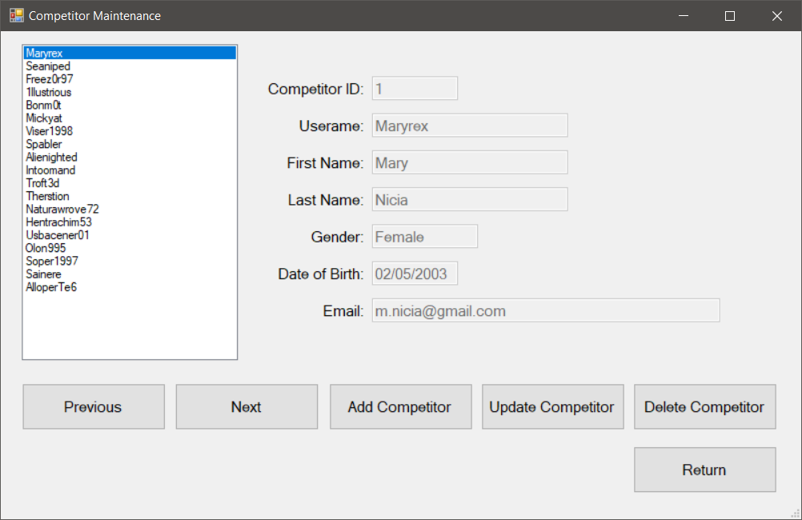

Competitor Maintenance: Screen Design 2
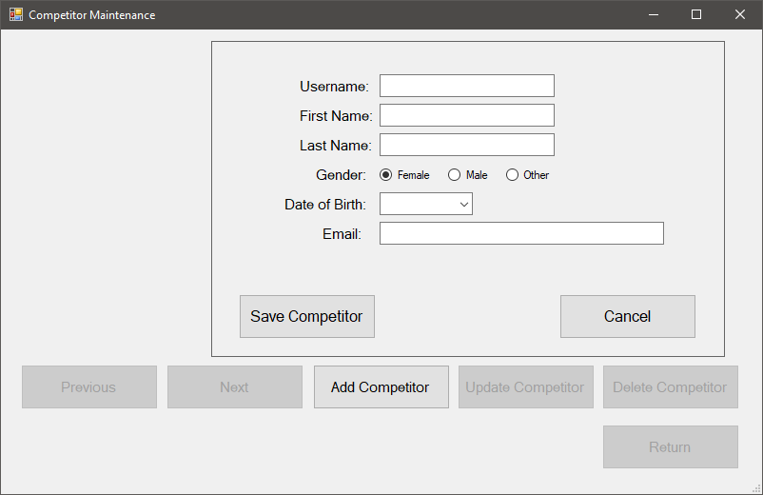

Competitor Maintenance: Screen Design 3
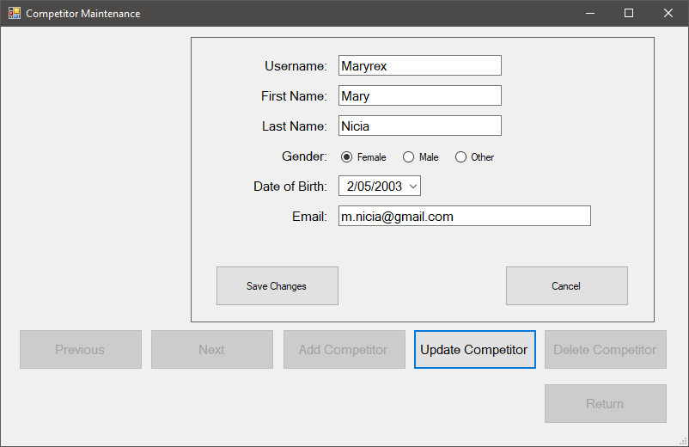

Task 5: Event Maintenance

- Display the Events’ names in a list.
- Allows the user to navigate between Events in the list.
- Display a selected Event’s details (Event id, Event name, status, capacity, event date, arena id, and arena name) in a read-only format.
- If the user clicks on the Add Event button, then
  - The Previous, Next, Return, Update Event and Delete Event buttons are disabled and the list should disappear.
  - A panel should appear (showing Save Event and Cancel buttons) allowing the user to enter values for the new event’s name, status (using a combo box), capacity (using a number picker), event date (using a date picker), and arena (using combo boxes).
  - If the user enters valid data for all fields and clicks on the Save Event button, then a new event record is saved in the database and the message “Event added successfully” is displayed.
  - If the user clicks on the Cancel button then panel should disappear, the Previous, Next, Return, Update Event and Delete Event buttons are enabled and the list should reappear.
- If the user clicks on the Update Event button, then
  - The Previous, Next, Return, Add Event and Delete Event buttons are disabled and the list should disappear.
  - A panel should appear (showing Save Changes and Cancel buttons) allowing the user to change the values for the event’s name, status (using a combo box), capacity (using a number picker), and event date (using a date picker).
  - If the user makes valid changes to any of the allowable fields (event name, capacity, event date, and status) and clicks on the Save Changes button, then the event record is updated in the database and the message “Event updated successfully” is displayed.
  - If the user clicks on the Cancel button then the panel should disappear, the Previous, Next, Return, Add Event and Delete Event buttons should be enabled and the list should reappear.
- If the user clicks on the Delete Event button and the selected event has no challenges, then the user is asked to confirm the deletion – if the user confirms the deletion then the event is deleted from the database and the message “Event deleted successfully” is displayed.
- If the user clicks on the Delete Event button and the selected event has challenges, then the error message “You may only delete events that have no challenges” is displayed.
- If the user clicks on the Return button, then focus is returned to the Main Menu.

Required tests:

  - Add a new event with valid data in all fields.
  - Update an existing event’s name with valid data.
  - Update an existing event’s date with valid data.
  - Delete an existing event that has no challenges.
  - Attempt to add a new event with an invalid name but with valid data in all other fields.
  - Attempt to update an existing event with an invalid name.
  - Attempt to delete an existing event that has challenges.

Event Maintenance: Screen Design 1
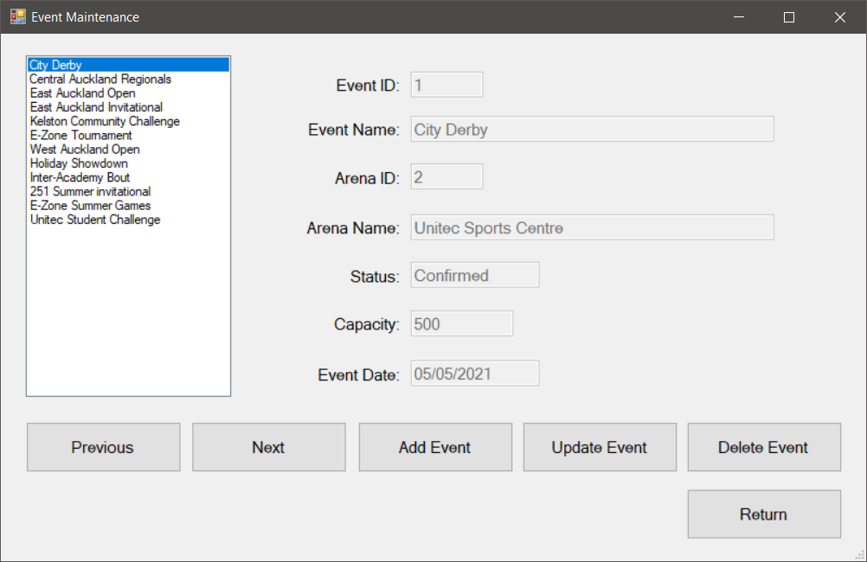

Event Maintenance: Screen Design 2
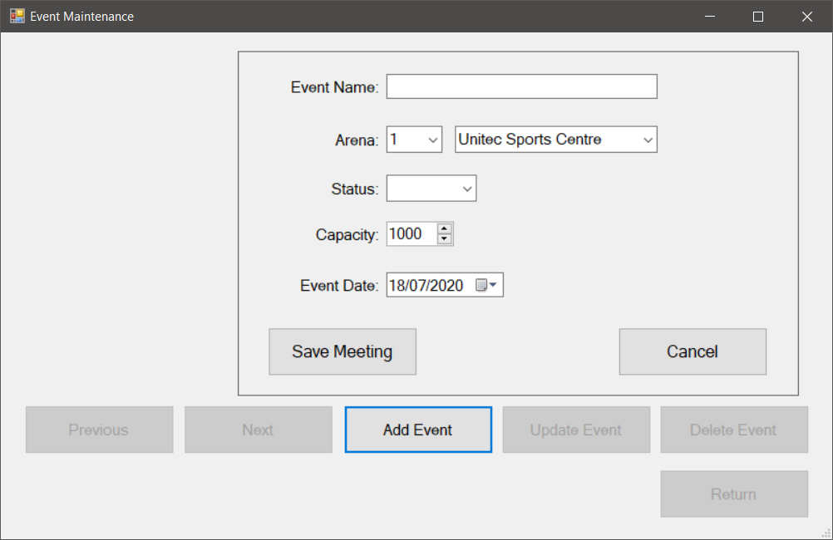

Event Maintenance: Screen Design 3
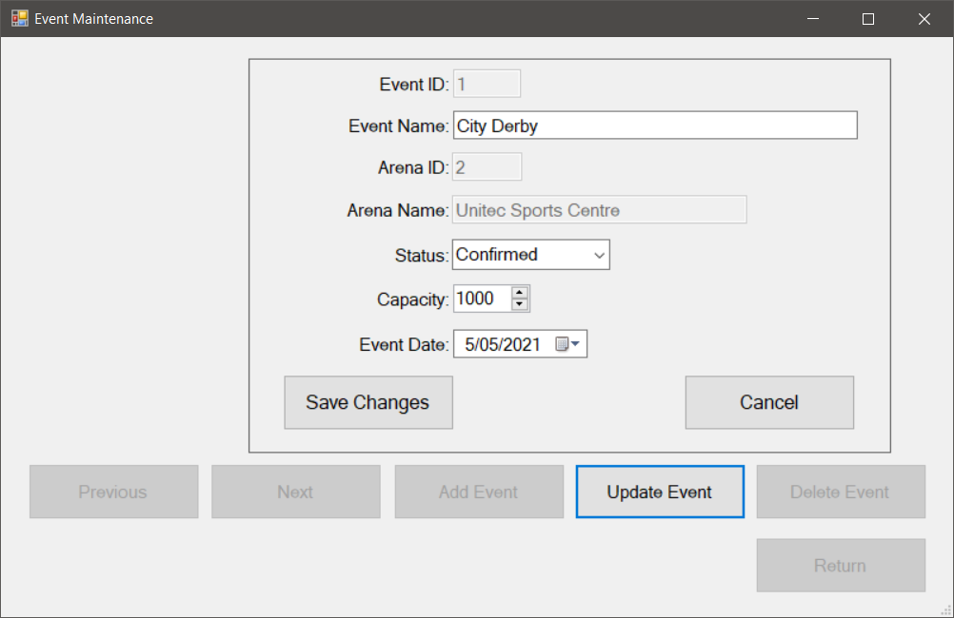

Task 6: Enter Competitors into Challenges

- Display the competitor’s details (competitor id, username, first name, last name, gender, date of birth, and email) in a data grid view.
- Display the challenges’ details (challenge id, challenge name, time, status, capacity, and event id) in a data grid view.
- If the user clicks on a row in the challenge data grid view, then the challenge’s event’s status should be shown in a read-only text box.
- Display the entries’ details (challenge id, competitor id, status) of all of those competitors linked to the selected challenge in a data grid view.
- If the user selects a competitor and a status and clicks on the Add Entry button and the status of the challenge is scheduled, then the entry record saved in the database and the message “Entry added successfully” is displayed.
- If the user selects a competitor and a status and clicks on the Add Entry button and the status of the challenge is not scheduled, then the message “Competitors can only be entered to scheduled challenges” is displayed.
- If the user clicks on the Remove Entry button, then the user is asked to confirm the removal – if the user confirms the removal then the entry is deleted from the database and the message “Entry removed successfully” is displayed.
- If the user clicks on the Return button, then focus is returned to the Main Menu.

Required tests:

  - Add a competitor to a scheduled challenge
  - Remove a competitor from a finished challenge
  - Remove a competitor from a scheduled challenge
  - Attempt to add a competitor to a finished challenge
  - Attempt to add a competitor to a completed challenge

Entry Maintenance: Screen Design
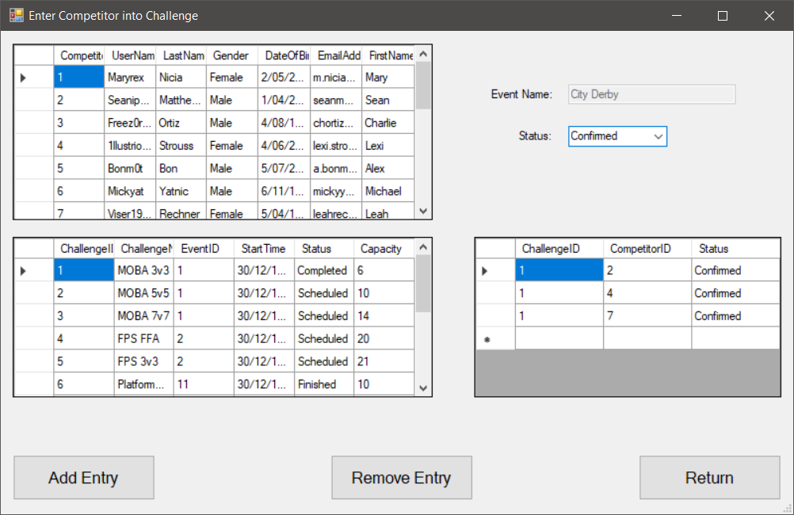

Task 7: Competitor Report

- This must allow the user to print (on a print form) a report called ‘Competitors’ that shows, for each Competitor with challenge entries, the Competitor ID, Username, first name, last name, gender, date of birth, email, challenge ID, challenge name, start time. One Competitor per page. Please note that Crystal Report is NOT to be used for this task and the report is to be produced using Master-Detail relationships in conjunction with ‘for-each’ loops. Please find below the logic that produces a display version this report – this logic needs to be adapted for producing the printed report:

LOOP FOR EACH Competitor in the COMPETITOR Table
Get the entries for the Competitor
If Competitor has entries, THEN
OUTPUT Competitor details (Competitor ID, Username, First name, Last name, Gender, Date of birth, Email)
LOOP FOR EACH Entry (associated with Competitor ID) in the ENTRY table
Get the challenge for the Entry
OUTPUT Challenge details (Challenge ID, Challenge name, Start time)
END LOOP
END IF
END LOOP

Required tests:

  - Produce the report with all requested fields present.

Competitors Report: Screen Design
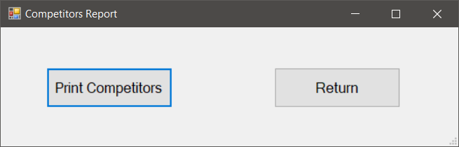
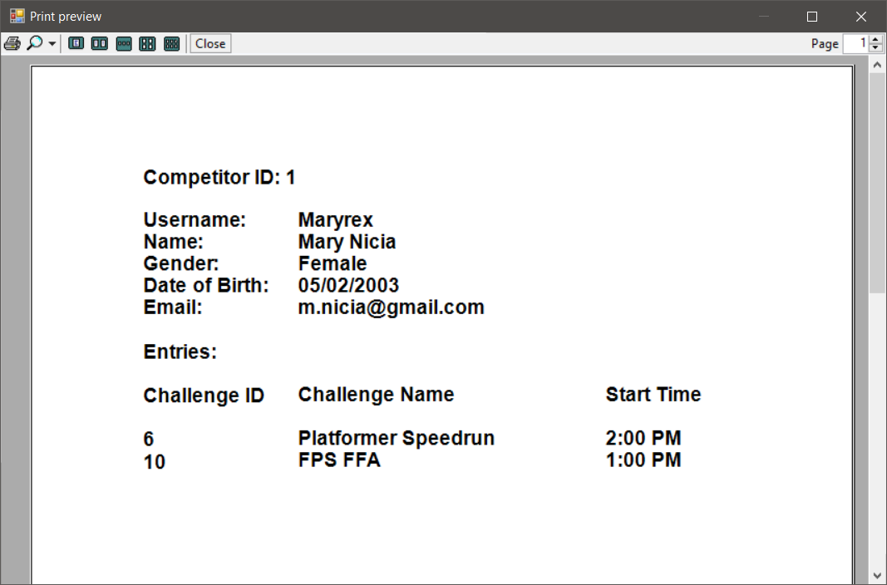

Task 8: Event Report
- This must allow the user to print (on a print form) a report called ‘Events’ that shows, for each event, event ID, event name, arena name and address, event date, and the details (challenge id, challenge name, and start time) of each of the event’s challenges. One event per page. Please note that Crystal Report is NOT to be used for this task and the report is to be produced using Master-Detail relationships in conjunction with ‘for-each’ loops. Please find below the logic that produces a display version this report – this logic needs to be adapted for producing the printed report:

LOOP FOR EACH Event in the EVENT table
Get the Arena for the Event
OUTPUT Event details (event id, event name, arena name and address, and event date)
Get the Challenges
If the Event has Challenges, THEN
LOOP FOR EACH Challenge
OUTPUT Challenge details (Challenge ID, Challenge Name, Start Time)
END LOOP
ELSE
Output “This event has no challenges scheduled.”
END IF
END LOOP

Required tests:

  - Produce the report with all requested fields present.

Events Report: Screen Design
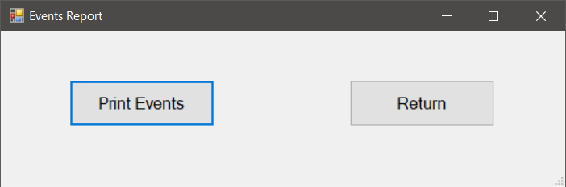
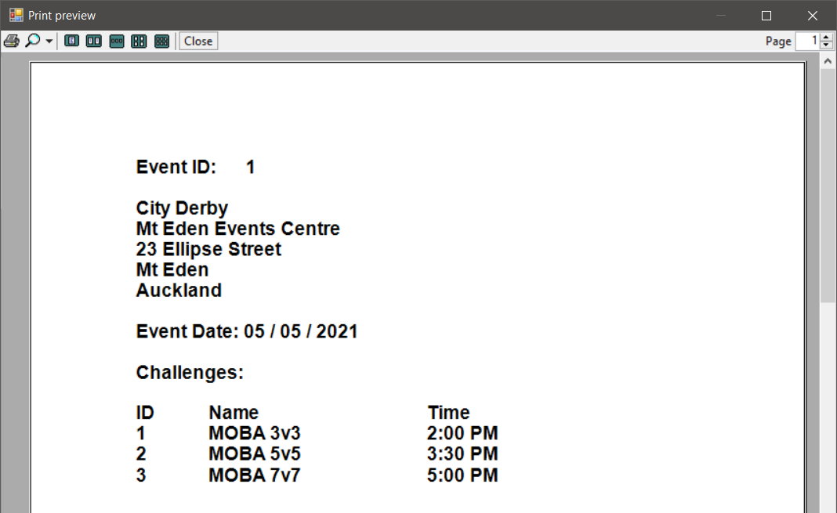

Marking

It is expected that the code for each of the program tasks that you finish does not contain compilation errors (i.e. no marks will be awarded if the code does not compile). Your application must update the database every time the user changes the data. You are also expected to handle exceptions by using MessageBoxes and “try and catch” blocks.

Requirement | Marks
Task 1: Main Menu | 6
Task 2: Arena Maintenance | 6
Task 3: Challenge Maintenance | 9
Task 4: Competitor Maintenance | 8
Task 5: Event Maintenance | 8
Task 6: Enter Competitors into Challenges | 18
Task 7: Competitors Report | 9
Task 8: Events Report | 7
Testing Documentation (Minimum 25 Test Cases) | 25
Naming conventions and correct internal documentation | 4
Total: | 100

Notes on marking

- Marks will be deducted for any task that is either not fully functional or not tested adequately.
- Check “Programming Standards for C Sharp Courses” at the end of this document. The standards for C# programming in this document MUST be followed. In particular, this includes putting meaningful comments at the beginning of each and every method in the standard format as given in the document.

Have a query? Want to improve your work?
You could:
- Visit Student Learning and Achievement for learning advice and support.
- Visit the Pacific Centre.
- Visit Te Noho Kotahitanga Marae (building 171)

Lecturer Assistance

If you have any questions about the assignment, then please email them to me. If you require assistance with your assignment, then please make an appointment outside of class time to see me. Please keep a record of all the work that you do on your assignment in a progress log (use the template provided on the next page).

Deadline for questions

Please note that there is a deadline for questions on the assignment at 8:30 a.m. on Monday 24th August 2020. Please make sure that you ask any questions regarding the assignment before this deadline.

Assignment 1 Progress Log

If you require any help while doing your assignment, please make sure that you bring along your up-to-date progress logs. Use the template below:

Date & Time:
Name of current version of project:
Task(s) undertaken:
Source(s) of solution(s):
Problem(s) encountered:
Progress made:
Name of new version of project:
Time Taken:

Deliverables

Soft Copy

The soft copy of the assignment is to be submitted in one *.zip (zip up your project while it is in the C:\Temp folder and please do not use any other formats such as .rar) file via Moodle and is to include:

- A soft copy of ALL files needed to compile and run your application from the Visual Studio .NET Community 2017 environment used in the Department of Computing labs. Please note that you must submit your assignment in Visual Studio .NET Community 2017. 30 marks will be deducted if this is not done.
- Testing documentation.
- Progress Log

Please note that it is important to upload the correct version of your assignment onto Moodle. If you submit the wrong version onto Moodle, please notify me by email before the deadline date or late penalties may be incurred.

User Interface

Always provide the users with clear instructions explaining what they should do. Areas used for input must be labelled to explain what input is required. Use hints or tool tips to explain interface features. The user must be prevented from entering values or taking actions that the program is unable to deal with. All input should be validated (use the MS Access database tables to see what is allowed in each field) and to see which fields are required); any errors found should be reported back to the user with an error message which clearly and politely explains how to correct the error. The user should be unable to proceed without correcting invalid input.

Assignment Delivery

Electronic submission of all of the necessary files is required for ALL assignments and must be submitted prior to 8:30am on the due date. Assignments submitted after the due date and time without having received an extension through Affected Performance Consideration (APC) will be penalised according to the following:
• 10% of marks deducted if submitted within 24hrs of the deadline
• 20% of marks deducted if submitted after 24hrs and up to 48hrs of the deadline
• 30% of marks deducted if submitted after 48hrs and up to 72hrs of the deadline
• No marks will be awarded for an assignment that is submitted later than 72hrs after the deadline.

For the purposes of academic integrity, students who haven’t demonstrated progress work in the class time can be asked to demo/test their working code and explain logic to the lecturer individually after assignment submission.

Affected Performance Consideration

A student, who due to circumstances beyond his or her control, misses a test, final exam or an assignment deadline or considers his or her performance in a test, final exam or an assignment to have been adversely affected, should complete the Affected Performance Consideration (APC) form available from Student Central.

When requesting an APC for an assignment, the APC application form must be submitted (along with work completed to-date) within the time frame of the extension requested; i.e. if the Doctor’s certificate is for one (1) day, then the APC application form and work completed must be submitted within one (1) day.

Assistance to other Students

Students themselves can be an excellent resource to assist the learning of fellow students, but there are issues that arise in assessments that relate to the type and amount of assistance given by students to other students. It is important to recognise what types of assistance are beneficial to another’s learning and also what types of assistance are unacceptable in an assessment.

Beneficial Assistance

- Study Groups.
- Discussion.
- Sharing reading material.
- Testing another student’s programming work using the executable code and giving them the results of that testing.

Unacceptable Assistance

- Working together on one copy of the assessment and submitting it as own work.
- Giving another student your work.
- Copying someone else’s work. This includes work done by someone not on the course.
- Changing or correcting another student’s work.
- Copying from books, Internet etc. and submitting it as own work. Anything taken directly from another source must be acknowledged correctly: show the source alongside the quotation.

For the purposes of academic integrity, students who haven’t demonstrated progress work in the class time (and/or no check point submission) can be asked to demo/test their working code and explain logic to the lecturer individually after assignment submission.

Programming Standards for C Sharp Courses

Internal Documentation

- Your code is such that other programmers can read it without struggling and your users are not left guessing as to what to do.
- Each class file (including form classes) will begin with comments explaining the purpose of the class, the author and the date written.
- Each method will start with comments that explain what the method does.
- Any code which does not have an obvious meaning or which uses a specialized technique is to be commented. Use blank lines and further comments to identify where parts of a task begin within a method.
- Code will use meaningful variable, class and method names. Components which have event handler code for any of their events must have meaningful names. Components which have properties assigned to in code must also have meaningful names. A naming convention that identifies the type of component involved is recommended. e.g. btnExit, txtStartDate, lblTotal

Layout

- Code will be laid out in the style of the example below, using indentation steps of 4 spaces. Blocks using { and } will use the layout shown here:

///<Summary> method: btnLeapYear_Click
///Check if a date falls in a leap year
///</Summary>
private void btnLeapYear_Click(object sender, System.EventArgs e)
{
DateTime aDate = getDate();
if ( DateTime.IsLeapYear(aDate.Year) )
{
label6.Text = aDate.Year.ToString() + " IS a leap year";
}
else
{
label6.Text = aDate.Year.ToString()
+ " is NOT a leap year";
}
}

- Parentheses and spaces will be used to make the meaning clear in arithmetic expressions and conditions:
sum = (n1 / n2) + n3;
not
sum = n1 / n2 + n3;
not
sum=n1/n2+n3;

- In general, each method will perform a single simple task.
- In the final version of your project please delete all sections of code that have been ‘commented out’

